ASSIGNMENT 1

Design a table follow the image below:

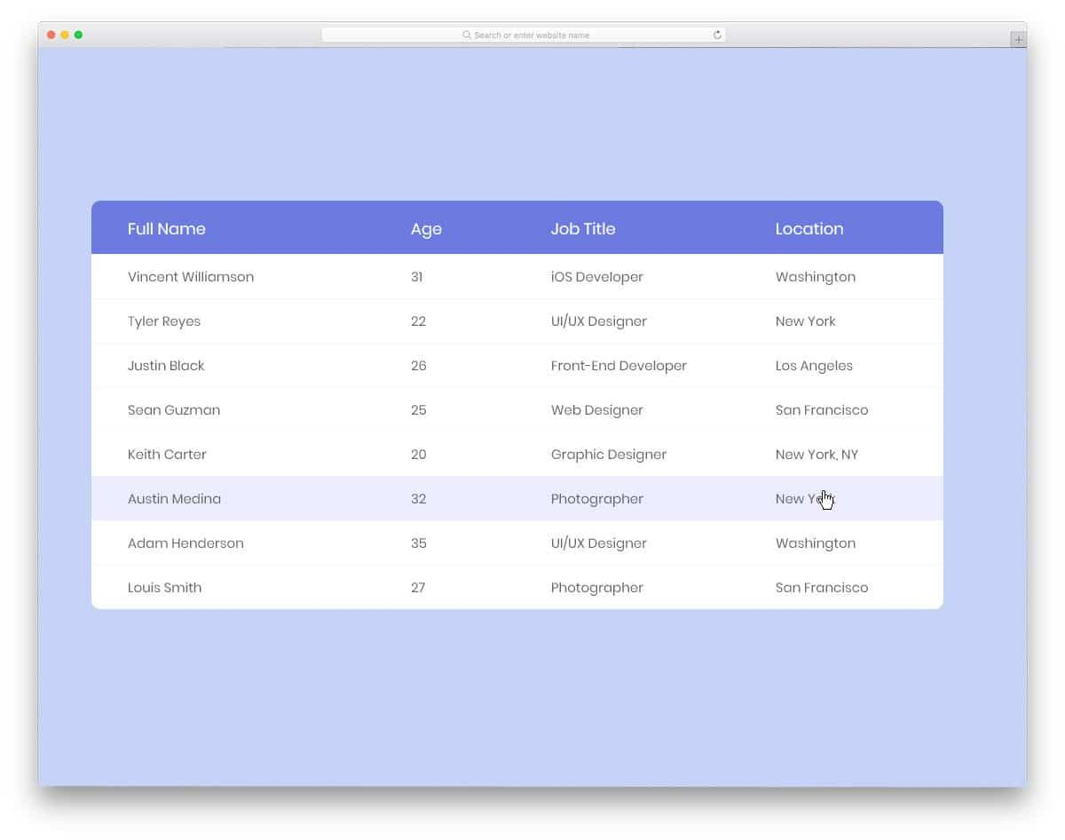

ASSIGNMENT 2

Design a table follow the image below:

